Sputnik Capstone Test Plan

Jake Heath

Mike Mathis

Shan Quinney

William Harrington

**Table of Contents**

**Revision History 1**

**1.0 Introduction 2**

**1.1 Purpose 2**

**1.2 Testing procedure 2**

**1.3 Recordings of Results, witnessing, and Authorities 2**

**2.0 Reference Documents 2**

**2.1 Design Documentation 2**

**3.0 Overview 3**

**3.1 Operational Description 3**

**4.0 Preparation 3**

**4.1 Test Equipment 3**

**4.2 Test Setup and Calibration 3**

**5.0 System Tests 4**

**5.1 10km Radio Test 4**

**5.2 System Controller Watchdog Test _______5**

**5.3 Test ______ 6**

**Revision History**

|  |  |  |  |
| --- | --- | --- | --- |
| **Revision** | **Date** | **Changes** | **Authors** |
| 1.00 | 03/03/2016 | Initial Release | Shan Quinney |
|  |  |  |  |
|  |  |  |  |
|  |  |  |  |
|  |  |  |  |

**1.0 Introduction**

**1.1** **Purpose**

The purpose of this document is to outline the essential testing that will be conducted to demonstrate the effectiveness of the Sputnik Capstone project. This test plan is not intended to be inclusive and additional testing procedures will be added if deemed necessary by any of the parties involved in the project.

**1.2 Testing procedure**

All of the testing described in this document will be carried out by one or more than one member of the Sputnik capstone team. An effort will be made to have the entire group present for as many of the tests as possible.

**1.3 Recording of Results, Witnessing, and Authorities**

The results of all testing conducted in this test plan will be displayed on the project wiki. The tests will be conducted on a pass/fail basis and any tests that do not pass will be noted in the documentation with an explanation as to why they did not pass.

No authorities or witnesses outside of the group will be required to be present during testing.

**2.0 Reference Documents**

**2.1 Design Documentation**

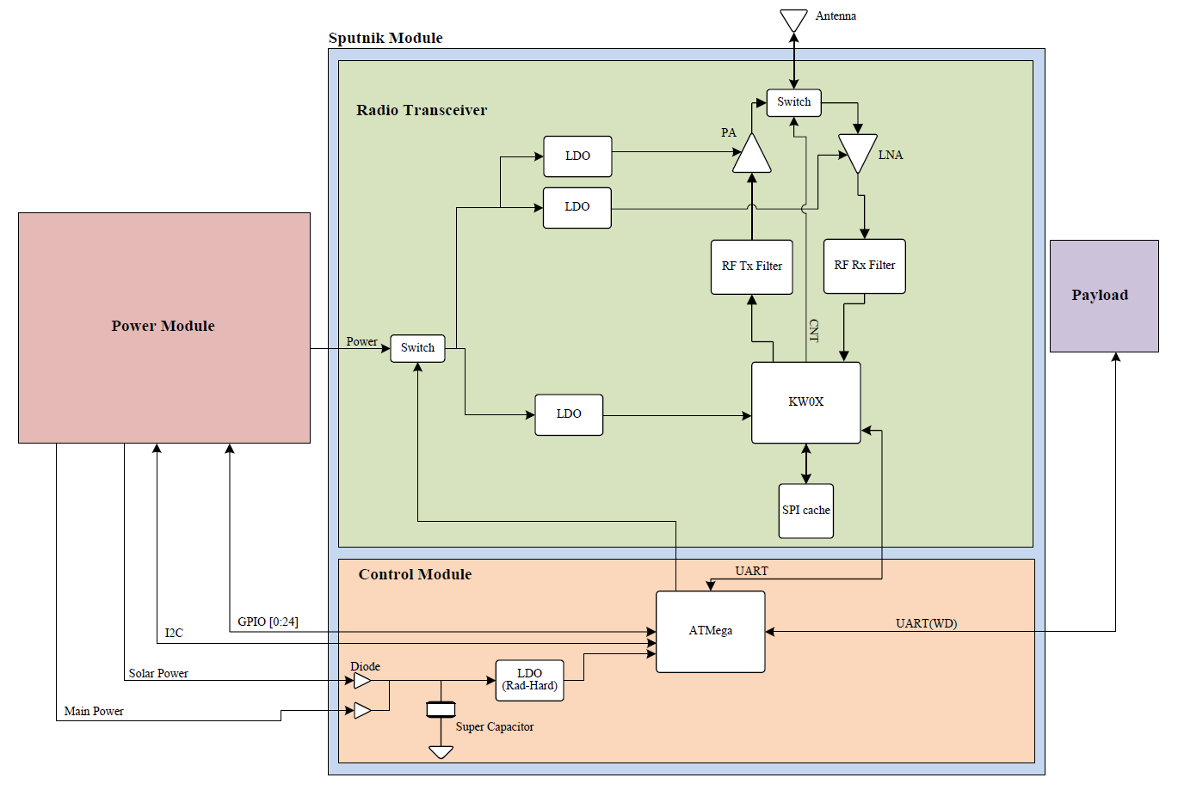

The Sputnik Capstone project is composed of two separate modules: The radio module and the control module. The radio module is home to the microcontroller with integrated radio transceiver, while the control module is designed to eventually house a radiation hardened watchdog controller that will help reboot the system after debilitating radiation events. For this project, the radiation-hardened components of the control module will be replaced with off-the shelf components to help reduce cost.

**3.0 Overview**

**3.1 Operational Description**

The Portland State Aerospace Society is sponsoring this capstone based on the need for a command, control, and communications system for their CubeSat project. The focus of this capstone will be rapidly prototyping this module. Sputnik will be responsible for long distance communications to and from a 400km low earth orbit, as well as, controlling and communicating with a payload that is housed within the CubeSat. On top of fulfilling these duties, it will need to be able to deal with a temperature range of -40C to 50C and radiation events that could cause components to latch up.

**4.0 Pre-test Preparation**

**4.1 Test Equipment**

The equipment needed for the tests is as follows:

* Multimeter
* JTAG connector
* Oscilloscope
* USB to micro-USB cable
* Logic analyzer

**4.2 Test Setup and Calibration**

The testing setup will be discussed for each case along with any necessary calibration.

**5.0 System Tests**

**5.1 10km Radio Transmission Test**

The radio is fundamental to the functionality of the Sputnik project. It provides the communication channel that will link the satellite to the ground station. Eventually, the radio will need to receive and transmit data for a distance of approximately 400km; however, for this project, only a transmission distance of 10km must be met.

The purpose of this test is to confirm that the radio is capable of 10km transmission and reception. This test will be performed from one radio board to another and the test givers will verify the distance covered during the test by collection GPS location data. The test locations will be predetermined based on both convenience and also where the least restricted signal propagation path will occur.

|  |  |  |  |  |  |  |  |
| --- | --- | --- | --- | --- | --- | --- | --- |
| Test Writer: | | Shan Quinney | | | | | |
| Test Case Name: | | 10km radio transmission | | | | Test ID#: | 10k_1.00 |
| Description: | | The purpose of this test is to ensure that the radio is capable of transmitting and receiving data at this distance. | | | | Box Type: | 🞎 white box  ✓ black box |
| Tester Information | |  | | | | | |
| Name of Tester: | |  | | | | Date: |  |
| Hardware Version: | | Sputnik radio board version 1.00 | | | | Time: |  |
| Setup: | | Determine location A and location B, where there is a minimal distance of 10km between points A and B. Have at least one team member located at location A and at least one other team member located at location B. Each location will have a Sputnik radio board with sufficient power supply. Each location will also have a method to verify GPS and time (cell phone). | | | | | |
| Step | Action | Expected Result | Pass | Fail | N/A | Comments | |
| 1 | Radio at location A is made to transmit data. | Team member at location B confirms receiving data transmitted from location A. |  |  |  |  | |
| 2 | Radio at location B sends confirmation signal. | Team member at location A confirms receiving data from radio at location B. |  |  |  |  | |
| Overall Test Result: | | |  |  |  |  | |

**5.2 Controller Watchdog Test**

The controller is the guardian of the system. It is there to ensure that the system is functioning correctly and that if any unintended event causes component latch-up or system errors, the system can be cycled or rebooted to return stability. This control system is the second half of the project. Eventually, this system will consist of a radiation hardened ATMega controller with supporting radiation hardened LDO. For now, the controller is a standard, off-the-shelf ATMega chip.

To test the control system, a method to simulate a latch-up event will be used to trigger the watchdog into action. Three such methods will be outlined in this test. The first is the kwox lock-up test. In this test, the crystal on the kwox will be shorted to cause an error in the radio system. The ATMega should sense that the radio is no longer functioning properly and trigger the reset line on the kwox to initiate a reboot.

|  |  |  |  |  |  |  |  |
| --- | --- | --- | --- | --- | --- | --- | --- |
| Test Writer: | | Shan Quinney | | | | | |
| Test Case Name: | | Controller watchdog test | | | | Test ID#: | ATM_1.00 |
| Description: | | The purpose of this test is to demonstrate the effectiveness of the watchdog to restart key system functionality after radiation events. | | | | Box Type: | 🞎 white box  ✓ black box |
| Tester Information | |  | | | | | |
| Name of Tester: | |  | | | | Date: |  |
| Hardware Version: | | Board Rev.1, Filter Rev.1, Wire antenna | | | | Time: |  |
| Setup: | |  | | | | | |
| Step | Action | Expected Result | Pass | Fail | N/A | Comments | |
| 1 |  |  |  |  |  |  | |
| 2 |  |  |  |  |  |  | |
| 3 |  |  |  |  |  |  | |
| 4 |  |  |  |  |  |  | |
| Overall Test Result: | | |  |  |  |  | |

**5.3 Last test**

|  |  |  |  |  |  |  |  |
| --- | --- | --- | --- | --- | --- | --- | --- |
| Test Writer: | |  | | | | | |
| Test Case Name: | |  | | | | Test ID#: |  |
| Description: | |  | | | | Box Type: | 🞎 white box  ✓ black box |
| Tester Information | |  | | | | | |
| Name of Tester: | |  | | | | Date: |  |
| Hardware Version: | |  | | | | Time: |  |
| Setup: | |  | | | | | |
| Step | Action | Expected Result | Pass | Fail | N/A | Comments | |
| 1 |  |  |  |  |  |  | |
| 2 |  |  |  |  |  |  | |
| Overall Test Result: | | |  |  |  |  | |